Blue Mount Lookout
Compiled by David Endacott
January 2016
The information on which this is based has largely been provided by Bruce McKenzie of Trentham.
The first wooden tower, 30 ft high, was built privately, presumably in 1927, in his spare time by N. Williamson. In 1929 the Forest Commission wrote a letter Commending Williamson for his efforts.
Bruce McKenzie (Trentham) has a photocopy of a visitors book covering from 4/12/1927 to 11/11/1934. He can’t recall who has the original. There are approximately 1300 names and addresses. The first visitor being a J. Fletcher at 10.30 am on 4/12/1927. It is interesting that apparently FCV did not actively prohibit public access to the lookout, or if they did it was ignored in this instance.
It is not known by this writer how or by whom the tower was manned in its early years, privately or officially under FCV. Was Mr Williamson prompted to build it out of civic duty by the 1924 (or25?) fires.
Blue Mount and Newbury had earlier been called Garlick’s Lead. The summit of Blue Mount is picturesque with a lovely small cemetery nestled in a saddle in the bush a little below the tower. Local legend has it that at a picnic old Mrs Garlick took off a shoe and threw it over her shoulder saying “ When I die I want to be buried where it lands”. She obliged not long after and was duly buried and so the cemetery became informally established. After more burials it was eventually surveyed and legally established. Her grave is by the Laurel tree near the entrance gate.
The West cemetery fence is not in the correct position and the track up to the tower is actually on cemetery land.
The original track to the summit came from the Newbury (Garlicks Lead) township to the West directly up through Trewhella’s property.
Frank Brady, a large man and an FCV employee did lookout duty and practised the bagpipes whilst there. He used to go home to Trentham and practise more in the bush near his house.
It is not known whether the 1927 wooden tower survived through to 1979. It may have been replaced with a more substantial wooden structure, it does look flimsy in the photo. I can recall going up it in the 50s as a kid but do not recall the structure with clarity. What did impress me was resident telescope. (I think my recollection is right, but it might have been Mt Blackwood) At Mt Franklin in the 50s Col Ruehland and Les Schultz “only” had field glasses. As a kid in the 50s with my father Norm being DFO Daylesford I often visited these places with him or the work crew.
As reported in the FCV Annual Report 1978-79, the wooden tower was replaced with the present steel tower.
A contract was let under seal to Ancol Engineering Pty Ltd to fabricate and supply three steel fire towers at a cost of $28,654. In the course of the year, four towers were replaced at Delegate Hill in the Orbost forest district, Fryers Hill in Castlemaine forest district, Blue Mount in Trentham forest district and Mt. Lonarch in Beaufort forest district. The old wooden tower on Mt. Nowa Nowa was given preservative treatment and retained as a tourist look-out. … P41
According to the BOM website the weather station near the tower was established in 1927.
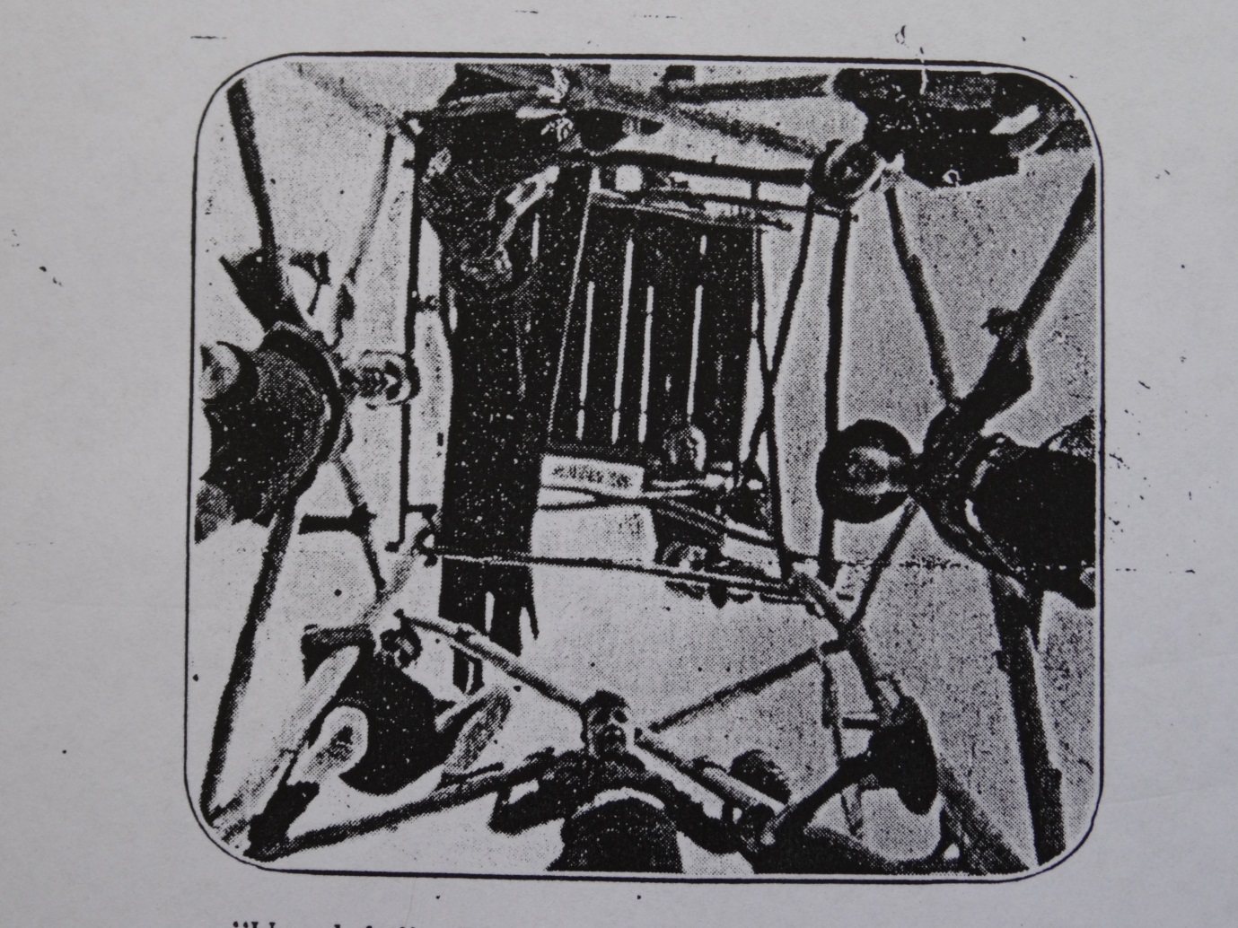

Scouts visiting. Date unknown. See caption below, obviously the photo won a prize of seven and sixpence somewhere.

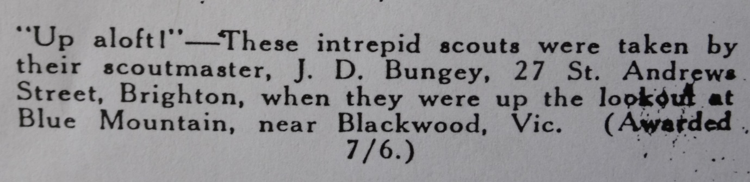

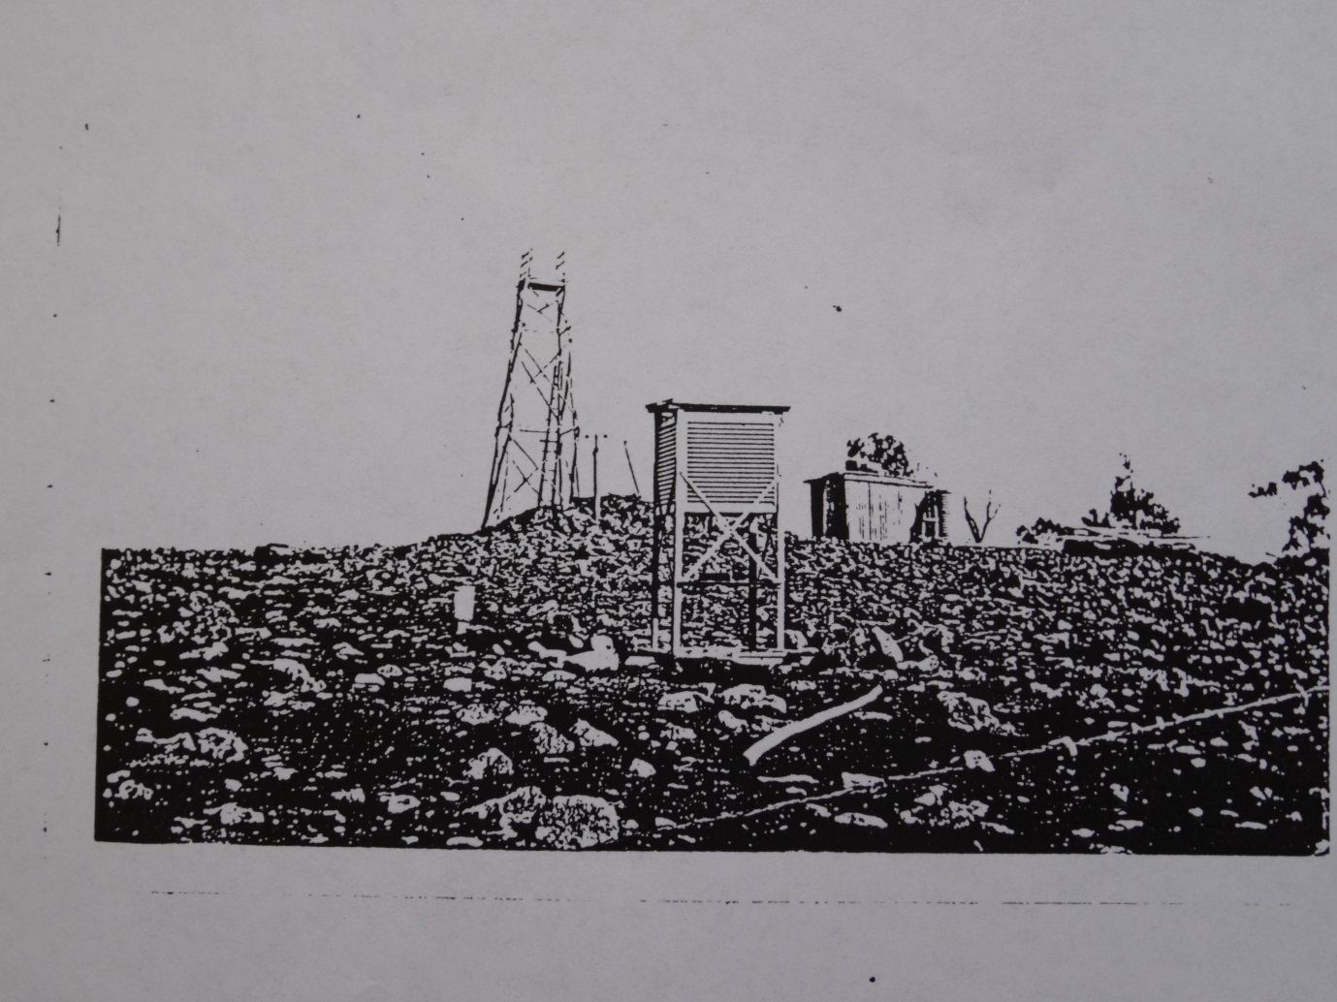
Blue Mt Tower with Hut and Stevenson Screen weather station. Date unknown.
Both photos and the letter on the next page courtesy of Bruce McKenzie, Trentham. Unfortunately the quality is not good as they were taken off a photocopy, the location of the originals not being known.
